Lesson Plan Template
Value Unit – Lesson 3

Activity Title: Learning Artistic Techniques - Shading/Value colored pencil

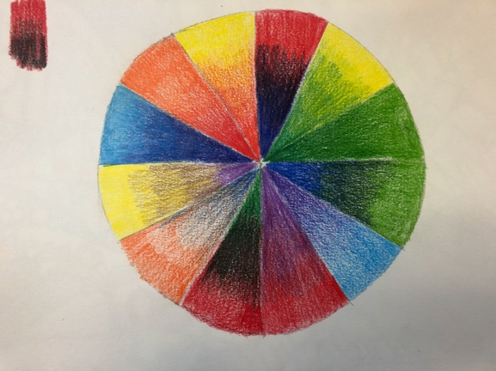
Teacher: Heidi

Grade Level: 6-8

Media: Drawing – Colored Pencil shading techniques

Time/Number of Sessions: 2 -45 minute sessions

Objectives:
VA7.CR.3 Engage in an array of processes, media, techniques, and/or technology through experimentation, practice, and persistence.
- Demonstrate a variety of skills and techniques for two dimensional and three-dimensional works of art.
VA7.CN.2 Develop life skills through the study and production of art.
- Identify and build art skills and habits of mind that support a variety of careers (e.g. higher order thinking skills, tolerance for ambiguity, judgement in the absence of rule, finding structure in apparent disorder, problem solving skills, perseverance, creativity)

Evaluation/Assessment: Students will be asked to complete a series of drawings to show mastery and understanding of the techniques of shading using colored pencil. The blending two to three colors of colored pencils techniques will be practiced for mastery in this exercise. Student work will be judged using a rubric with the main focus on skill mastery, completeness. and craftsmanship.

Procedure:
- Students will follow along with the demonstration given on how to use several colors of colored pencils to show changes in value.
- Students will draw a circle with 12 sections like a color wheel to experiment with blending two to three colors of colored pencils together. They will include the complementary color combinations in 3 of the sections.
- Students will upload their finished work by taking an image into the CTLS system for grading.
- Students will reflect on experience for an exit ticket.

Art Materials: sketchbook, colored pencils 12 colors or more, pencil, eraser, sharpener

Vocabulary:
Value
Shading
Blending
Complementary colors
Analogous colors
Warm Colors
Cool Colors
Monochromatic

Technology: Document camera, interactive panel, youtube video on shading with a colored pencil: https://youtu.be/5dG9WYOvPAE

Accommodations:
Students with learning disabilities will need to have extra help with these techniques, their para-pro, or I can sit and give one on one direction for small amounts of time to help them with the technique once the work session has begun.
ELL students will need to be checked for understanding of the task. The translator app will be used to translate into their native language in the event that instructions were fully understood. Most will be able to follow along the visual demonstration with the class.

Interdisciplinary/Cultural Connections:
Shading teaches attention to detail, patience and perseverance. This lesson develops drawing skills that will help with hand-eye coordination, hand strength, neatness, and craftsmanship. These skills are valuable for writing, math, and science when paying attention to detail.

